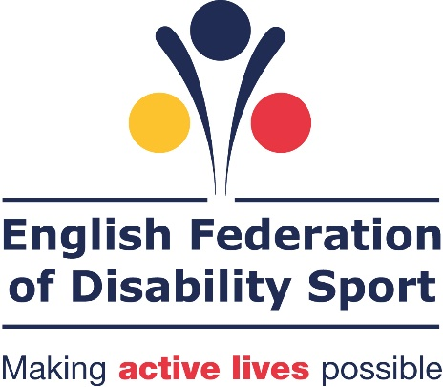

Supporting me to be active:
The role of supporters in influencing disabled people to be active

January 2016
A report by the English Federation of Disability Sport, based on research conducted by Future Thinking



Report findings based on market research conducted in May to August 2015 by FutureThinking on behalf of the English Federation of Disability Sport.

Contents
Introduction 4
Research Objectives 5
Methodology and sample 6
Executive summary 7
Section 1: The level of influence a supporter has in encouraging a disabled person to be active 9
Section 2: The type of support provided to enable a disabled person to be active 13
Section 3: The benefits of a disabled person being active 16
Section 4: The barriers to disabled people being active 19
Section 5: What a supporter needs to know about an activity 25
Section 6: How to communicate the information to supporters 28
Section 7: How supporters seek information 32
Conclusion 34

Introduction

Over the past four years EFDS has focused its research on gathering disabled peoples own views and opinions about what they want and expect from sport and physical activity. We have used this information to help providers improve their offers to make them more suitable and appealing.

Our research has shown that disabled people often have smaller social networks who they rely on to a greater extent for day to day support. We believe that the people in these social networks could play a significant role in encouraging and supporting disabled people to be active.

Based on this assumption we are now widening our research focus to speak with ‘supporters’ of disabled people - friends, family, and professional paid support - to understand how their views and opinions of sport and physical activity may influence disabled people to be active.

Please note that the views and opinions in this report are from the perspective of the supporter so may vary from some views and opinions in previous research gathered from disabled people.

For this research EFDS partnered with the English Learning Disability Sports Alliance (ELDSA), a unique partnership between Special Olympics Great Britain (SOGB) and Mencap to promote the inclusion of people with a learning disability in sport and physical activity.

Research Objectives

The overall study aimed to answer the following questions:
- What are supporters’ own attitudes, drivers and barriers when it comes to sport and physical activity?

- What are the attitudes, drivers and barriers for supporters when it comes to sport and physical activity for the disabled people they support?
  - How are these influenced by supporters own views of sport and physical activity?

- What is the role of the supporter with regard to sport and physical activity for the disabled person – from thinking about participation through to active participation?

- If appropriate, how do supporters find information about new sport and physical activity for the disabled person they support?
  - What captures their attention?
  - What factors are important to consider?

It was a two-stage study. The objectives of stage one were:
- To understand what is preventing greater participation in sports and physical activity from a supporter point of view

- To determine how supporters can be engaged to help encourage and support greater participation in sport and physical activity

- To develop guidelines for providers in how to amend and adapt their promotion to attract the attention of supporters

The objectives of stage two were:
- To explore and test themes identified in stage one. To provide a further understanding on the role of supporters with regard to sport and physical activity for the disabled person they support.

Methodology and sample

The study ran from April until September 2015 and was a two stage study.

Stage one: Qualitative study
There were 26 one-hour face-to-face interviews with parents/ guardians or family and friends of disabled people. These people provided some level of support to enable the disabled person to complete daily tasks. Eight of the interviews included a 15-minute session with the supported disabled person.

Two 90-minute focus groups with 12 professional carers.

We recruited respondents to ensure a mix of:
- Relationship types to disabled person
- Disabled people’s impairments
- Age of disabled person
- Geography
- Level of participation in sport or physical activity by the supporter and disabled person

Stage two: Quantitative study
A 10 minute online survey with 611 participants recruited through an online panel
- 146 parents / guardians
- 318 friends and family
- 147 professional carers

Due to the partnership with ELDSA the sample was slightly biased to ensure a greater representation of people with learning disabilities.

Executive summary

Supporters play a key role in encouraging disabled people to be active.

9 in 10 supporters think it is important that disabled people are active because of the mental, social and physical benefits disabled people can get from taking part.
- In addition, the supporter themselves gain benefits from the disabled person being active

8 in 10 supporters state that they have some level of influence in encouraging disabled people to be active.

7 in 10 supporters think the disabled people they support would like to be more active, but there are too many practical and emotional barriers that currently exist.

Supporters offer a variety of emotional and physical support to help disabled people to be active.

The level of support provided differs widely depending on the needs of the disabled person.

The most common types of support given, provided by 6 in 10 supporters is motivating and inspiring disabled people with new ideas to be active or offering logistical support to enable them to take part. To do these roles effectively supporters need to know about and understand what opportunities are available.

The relationship the supporter has with the disabled person, and the extent to which they are personally active, impacts the level of influence they have. Also, how willing they are to recommend sport and physical activity to the disabled person.

To be willing to encourage and support a disabled person to be active, a supporter must be confident the activity is relevant and suitable.

In order to determine the relevance and suitability of an activity supporters need to know:
- Whether the activity will be safe for the disabled person to take part
- What the environment is like
  - How many other people will be there?
  - How much noise is there?
  - What age ranges are included?
  - How many staff will be present and what is their attitude like?
  - Can the supporter intervene in the activity if needed?
  - How long does it last?
- Who else will be taking part (disabled or non-disabled)
- What the facilities will be like
- If the activity will be competitive or for fun

To help supporters be confident about an activity, providers need to ensure relevant information is available

To overcome their concerns, providers need to ensure supporters can access information. It should answer the key questions about safety, facilities, environment, who the activity is for and whether it’s competitive or not.

To ensure supporters are aware of activities, providers need to use communications which target them directly and appeal to them. Providers should think about the imagery, language, examples and contact information that they will use which will appeal to supporters.

Providers should give more thought to the types of channels to reach this audience. Maximise your reach on the internet by ensuring your Search Engine Optimisation has relevant terms, focusing on location. And utilise the power of word of mouth by tapping into the networks that supporters use.

Section 1: The level of influence a supporter has in encouraging a disabled person to be active

8 out of 10 (79 per cent) say they would have some role in helping a disabled person decide to take part in sport or physical activity. There are four main factors that impact on the level of influence they have on this decision. These factors are shown in the table below.

Figure 1: What impacts the level of influence a supporter has on encouraging a disabled person to be active

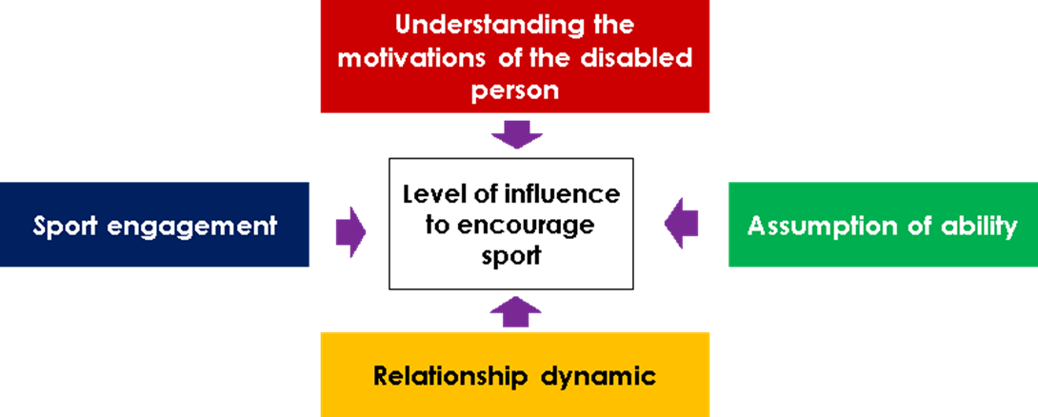

The diagram above shows four factors which impact the level of influence a supporter can have on a disabled person being active. These include understanding the motivations of the disabled person toward sport and physical activity, the level of engagement the supporter personally has with sport, the relationship dynamic between the supporter and the disabled person and the assumption the supporter has of the disabled person’s ability to take part in sport or physical activity.

- Understanding the motivations of the disabled person
The supporters often know a great deal about the disabled person. They understand their likes and dislikes as well as the restrictions the impairment may place on the disabled person’s life. They are therefore in a strong position to make judgements and recommendations about suitable activities and then recommend them.

The extent to which they suggest activities is based on a mix of the following:
- Activities they know the disabled person might enjoy
- Things that they know and enjoy themselves
- Discussion with the disabled person about the sport and physical activity they would like to try
- Trial and error based on past experiences
- Activities that they know the family and friends of disabled people are interested in or are already participating in
- What they know is available, suitable and safe

- Relationship dynamic
The type of relationship between the supporter and the disabled person can affect the decision-making process. It can have an impact on the extent to which they are involved in the decision and whether the disabled person tries an activity.

Parents are more likely to play a bigger role in the decision to be active. Over 8 in 10 (85 per cent) parents were involved in the decision, whereas only 7 in 10 professional carers say they are involved.

Figure 2: The level of involvement a supporter has in the decision of whether the disabled person they support takes part in sport
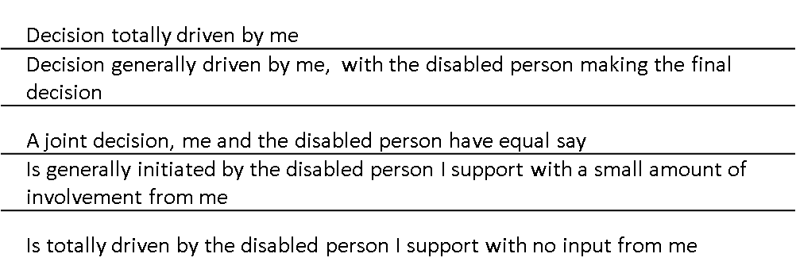
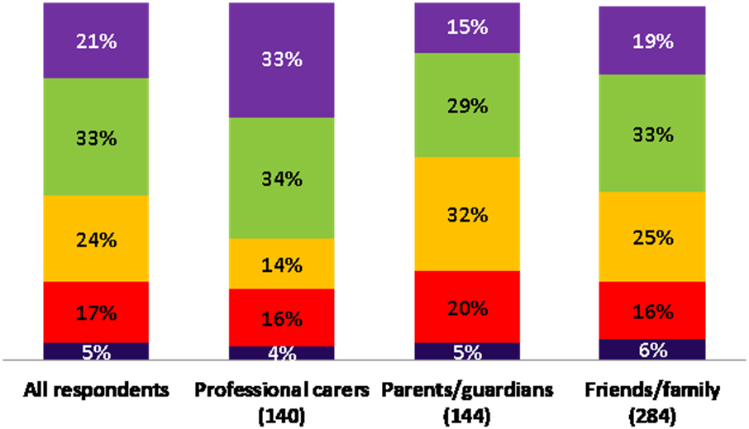

- Assumption of ability
Supporters have a view on how capable the disabled person they support would be at a particular activity. This can sometimes conflict with the disabled person’s views.

Previous EFDS research has shown that parents can sometimes be more cautious about their disabled child’s ability compared to their non-disabled peers and be more hesitant about suggesting or introducing them to potentially unsafe or unsuitable activities.

- Sport Engagement
There is a correlation between the activity levels of supporters and disabled people.

If disabled people are more active (participate in more than two 30 minute activity sessions a week) a greater proportion of their supporters are likely to be more active.

Figure 3: Chart showing the relationship between supporter activity levels and the activity levels of the disabled person they support

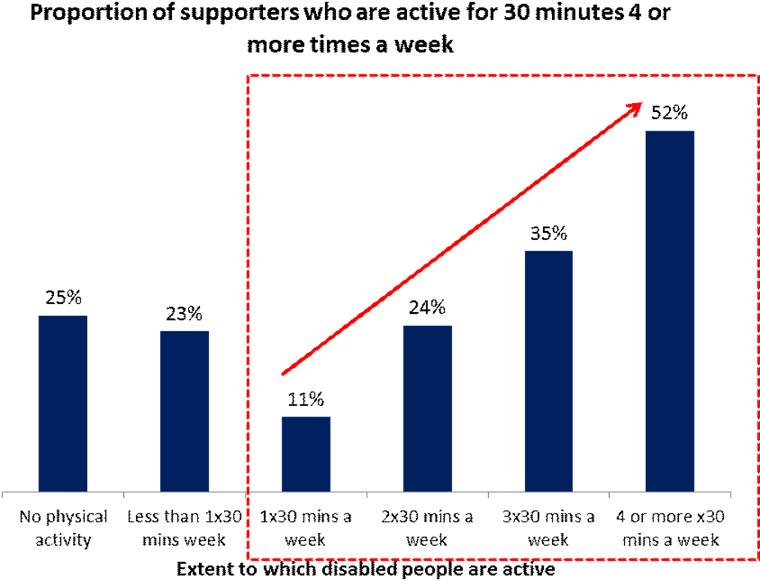

This suggests that people who are more active encourage others to be active too. This question alone does not explain who drives the increased participation (the supporter or the disabled person). However the rest of the research indicates that if a supporter is more active, they are more likely to encourage the disabled person to be active. This is because if a supporter is personally more active, they are more likely to understand the benefits that can be achieved from taking part. They have personal experience of those benefits so can be more persuasive as to why the disabled person should consider it. They are also more willing to find ways to try and overcome any barriers that may exists, because they believe the benefits of taking part are worthwhile.

Section 2: The type of support provided to enable a disabled person to be active

Supporters not only play a role in helping disabled people make a decision about being active, but 9 in 10 say that they provide a range of emotional and physical support

The level of support provided differs widely depending on the needs of the disabled person. Overall people with behavioural conditions or learning disabilities are more likely to receive support, whereas people with a visual impairment are least likely to receive support.

Emotional Support
Almost 8 in 10 (76per cent) supporters said they offered some kind of emotional support.

- 6 in 10 (57 per cent) act as a motivator or inspirer

This is the most common form of emotional support. The supporter acts as an idea generator. They suggest activities that they think would be suitable for the disabled person.

The relationship that supporters have with the disabled person often means they know enough about their likes, dislikes and capabilities to persuade, motivate and inspire them to do new things.

“It is very important for me to motivate Simon, if I didn’t he’d sit at home all day and be a couch potato” Supporter for person with Cerebral Palsy, Physical and learning impairment

This type of support is particularly prevalent among supporters of children and those with learning disabilities, autism and mental health conditions.

- 4 in 10 supporters (41per cent) act as a cheerleader or encourager

This is where the supporter generates positivity about an activity in order to encourage the disabled person to initially take part and continue doing so.

“It’s my mission to get him out into some fresh air, get him doing something active. I wouldn’t force it, it is their choice at the end of the day. But you really try to encourage them to go out” Professional Supporter

- 4 in 10 supporters (42per cent) act as a consoler or confidence builder

Supporters see confidence building as important in their role. It is all about helping the disabled person overcome their self-doubt of their ability to take part in activities.

This role is also about dealing with negative experiences. When there is a set-back, such as not enjoying an activity or not having the experience they expected, the supporter will do their best to build the person up and help them overcome their concerns.

In order for the supporter to be successful in this role, they themselves need to be confident an activity is suitable.

Practical Support
3 in 4 supporters (77per cent) said they offered some kind of practical support.

- 6 in 10 (61per cent) offer logistical and organisational support

This involves getting the disabled person to an activity. It usually involves some kind of role in transportation. From identifying suitable ways to get to an activity (e.g. public transport or a friend to drive), to driving the person to an activity and helping them in and out of a car at a venue. It can also include financial support.

“He can’t handle money and for that reason he can’t handle getting on a bus, so we had to find a place for him that was near enough for him to walk to, or that we could drive him to easily” Supporter of person with a learning disability

This kind of support is much more prevalent among parents and guardians

- 4 in 10 (41per cent)act as a researcher

They identify and research activities to determine how suitable they would be. Research can range from seeing a poster and relaying the information to going to great lengths to determine the suitability of an activity. This includes visiting facilities and speaking to providers to help overcome concerns.

“I do all the research, I have to look where it is, what it is, what it entails, how much it costs, because so many of these things are really, really expensive” Supporter for a person with cerebral palsy, autism and learning disability

- 4 in 10 (36per cent) provide hands on support and environment management

This involves the supporter helping the disabled person actually take part in the activity. The type and level of support provided can vary by person and depending on impairment type.

For people with sensory impairments support often revolves around the supporter being their ‘eyes and ears’, and helping people to take part safely.

For disabled people with an impairment that affects their mobility, the supporter provides assistance with changing, getting in and out of an activity or venue and potentially helping with the activity itself.

Supporters of people with learning disabilities or behavioural conditions talk more about their role in environment management. This refers to the assessment of the environment. They want to assess whether the disabled person they support will feel comfortable in the activity and enjoy the experience. To do this supporters often need to know more information about the other participants and the actual content of the activity. In this instance supporters may sit through an activity to ensure everything goes smoothly. For example a participant with learning disabilities may lose interest or focus, so a supporter is may need to interrupt the activity to get the person back on track.

Conclusion
Supporters have a clear role in influencing disabled people to be active. One of the primary forms of support they give is as an idea generator suggesting activities that the disabled person may enjoy.

In order for a supporter to suggest an activity they must be aware of it and feel confident that it will be relevant and suitable.

It is therefore important to ensure that these supporters have access to the relevant information that helps them feel confident that an activity is suitable.

Section 3: The benefits of a disabled person being active

The majority of supporters (9 in 10) think it is important for a disabled person to be active. This is because they believe there are numerous benefits for the disabled person and supporter if they are active.

The perceived benefits to the disabled person fall into three categories:

Figure 4: The benefits a disabled person can get from being active


- Mental health benefits
More than 8 in 10 supporters (85 per cent) said being active offers the disabled person some form of mental health benefit including:
- Improved confidence
- Personal development
- Improved mental health
- Achievement
- Pride
- Routine

“She just feels better, it improves her mood when she does actually do some exercise you can tell that she feels better in herself.” Supporter of someone with a learning disability

“Exercise is important, it allows you to clear your head. It’s not only good for your body but it’s good for your soul and your mind.” Supporter of someone with a visual impairment

- Physical health benefits
77 percent of supporters said that disabled people gain some form of physical benefit from participation, including:
- Improved physical health
- Increased mobility / coordination
- Physical development
- Increased energy levels
- Weight loss

“There are so many benefits – courage, confidence, but also with MS you deteriorate and I really want my mum to make her body strong for the future” Support of someone with physical impairment

“Exercise is absolutely essential, without it he could very easily become very sedentary and just sit. With exercise his appetite improves, his skin improves - physically, he improves. You can see the colour in his cheeks, the darkness go away from under his eyes. He sleeps better” Supporter of someone with autism

The impact that sport and physical activity can have on personal and physical development was more likely to be identified as a benefit by professional carers and parents. Whereas friends and family members were more likely to state that taking part in sport and physical activity allowed disabled people to spend time with the family, but also provided respite for the carer.

- Social benefits
8 in 10 (83 per cent) supporters identified some form of social benefit from taking part, including:
- Having fun
- Social interaction
- Making new friends
- Learning new skills
- Belonging to something
- Time with family
- Respite for carer

“Socialising and engaging, I’d say that is the biggest thing with my groups. I have them outside at dinnertime playing dodgeball and stuff. It’s the social side that’s important” Professional carer

Benefits to supporters
Disabled people being active does not only have benefits for the disabled person, but also the supporters.

- Pride / happiness for the disabled person
Supporters take joy from seeing the disabled person they support taking part in something, enjoying it and having the opportunity to get involved, develop and progress, develop or simply get involved.

“If she is happy, we are happy. It can be hard dealing with a negative daughter.” Supporter of someone with mental health condition

- Building a support network and making new friends
Supporters find it useful for themselves and also the disabled person, to have a network of people to call on for help. Having contact with those in a similar position gives the supporter a network to share ideas with and also friends that can help with coping

“When he was growing up, going to different activities with him enabled me to meet other mums in the same position and build up a bit of a support network that way.” Supporter of someone with cerebral palsy

- Respite
This benefit is specific to family and friends. They can sometimes use the time a disabled person spends at an activity as an opportunity for a break if they are confident that the environment and the activity is safe and supportive for the disabled person.

“It’s for the respite and knowing that he’s in safe hands and doing an activity that he enjoys.” Supporter of a person with a learning disability

- Learning new ideas
Activities are an opportunity for some supporters to get ideas from coaches, organisers and other supporters of things to try with the person they support.

Non-professionals who do not live with the disabled person specifically cite this as an environment for inspiration on activities. It is also a way to learn from more experienced people and build their own confidence as a supporter

“Particularly for me, as I’m quite new to it [supporting], it’s good for me to get ideas.” Supporter of a person with learning disabilities

Section 4: The barriers to disabled people being active

7 in 10 (72 per cent) supporters believed that the disabled people they supported wanted to do more physical activity. However, they a practical and emotional barriers preventing them.

Practical barriers

Figure 5: Chart showing the practical barriers in descending order (top 5)
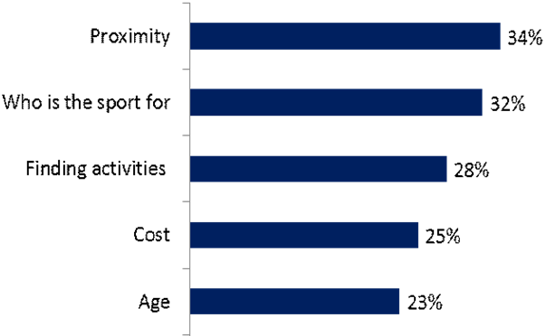

- Proximity
Identified as a barrier by 3 in 10 (34 percent)

The geographical distances that can exist regarding how close or far an activity is can be a significant barrier to a disabled person taking part. Mobility and transport options can be limited for disabled people, often with a reliance on others. Good proximity and clear transport options mean disabled people are more likely to attend an activity.

Mainstream local facilities are a great option for most as they are generally close by and open at convenient times. However, often there are limited options available at these venues, or what is available is not clearly communicated.

- Who the activity is for
Identified as a barrier by 3 in 10 (32 percent)

This refers to whether an activity is aimed specifically at disabled people, or enables disabled and non- disabled people to take part together in an inclusive environment. Different supporters seem different settings as more appropriate for the people they support.

7 in 10 disabled people have more than one impairment. This can mean that finding the right activity can be challenging. For example someone who is blind and arthritic will find it very difficult to find something which caters to their needs.

“We know so many people who do things but it’s all for one disability, not for the two combined.” Supporter of someone with a visual impairment

People seeking activities which are not ‘disability’ specific are often frustrated. Some disabled people do not want to take part in activities specifically for disabled people but do require an activity that allows them some level of support.

“He feels inadequate, he is able-minded but lacks in confidence. Things tend to be for disabled or mainstream, there is nothing in between” Supporter of someone with a physical impairment

Supporters feel that people with single impairments who prefer disability specific activities are best served as providers find it easier to identify these individuals and provide suitable activities for them.

“There are so many sports and activities available for blind people through things like Henshaws and the RNIB, she has lots of blind friends that take part in lots of activities” Supporter of someone with a visual and physical impairment

- Finding activities
Identified as a barrier by more than 1 in 4 (28 percent)

The first step of knowing what is available and where to start looking can be a significant barrier. Supporters say they find the task frustrating and time-consuming, which can prevent some from continuing to search.

“I just wouldn’t even know where to begin really, because she has such limited movement in her body I’ve never really thought of exercise and sport as something she could really do – I wouldn’t know where to begin “ Supporter of someone with a physical impairment

Even when activities are identified, supporters find there is not enough information available for them to make an assessment on the suitability of the activity. Getting to speak to the right person to seek the relevant information can also be difficult.

This is a particular frustration for family and friends who can have a more limited network from where to seek advice and recommendations.

- Cost
Identified as a barrier 1 in 4 (25 percent)

Half of supporters (55 per cent) said that financial restrictions prevented the disabled people they support from being more active. Professional carers and parents were more likely to claim this as a concern compared to friends/family.

The combined cost of paying for the activity, any associated equipment and travel costs can often add up to a prohibitive sum for some disabled people. In addition, supporters sometimes also have to pay in addition to the person taking part. Disabled people are often reliant on financial support to live which may not be adequate enough to cover the cost to taking part in an activity.

In addition, 6 in 10 supporters said that the person they support is concerned if they are seen to be active, it may impact the financial support they receive such as disability living allowance, making them very cautious about being active. Professional carers were more likely to say this was a concern.

- Age
Identified as a barrier by over 2 in 10 (23 percent)

Supporters feel that as a person gets older, the number of suitable opportunities decline. This is especially prevalent for supporters of people with a learning disability.

For people of pre-school age it is easier to find or adapt activities. The decision about whether to take part at this age is often driven by parents, with a focus on developmental goals. At primary school age participation is generally achieved at school, provided often in specialist settings so supporters are confident with the quality and suitability of provision.

If the disabled person is a teenager, sport in school is still an option, but becomes more challenging as teenagers start to explore their own identity and boundaries. Parents play less of a role in decision making. Teenagers can also be more likely to reject activities targeted at disabled people only. It also becomes more challenging to find play options that mirror those for younger children for older teens who have not moved beyond play.

For adults, they are not connected to the school system anymore, so finding suitable and available activities becomes very difficult. In addition, without support from schools to drive and aid participation, greater responsibility is given to supporters.

For those with physical impairments it can be difficult to find suitable opportunities that have the right age group associated with it. All participants generally have a desire to socialise with those of a similar age/ life stage.

“Most people with my condition are older, so I get invited to things, but everyone else is 70. They are all very nice, but there are just limited things for people my age” Supporter of someone Visual Impairment

“It really needs to be young men [within the group], similar to him so it can be social” Supporter of someone with a physical impairment

For people with acquired impairments, often they do not have an established network to use to help to find suitable activities

Emotional barriers

Figure 6: Chart showing the emotional barriers in descending order (top 5)
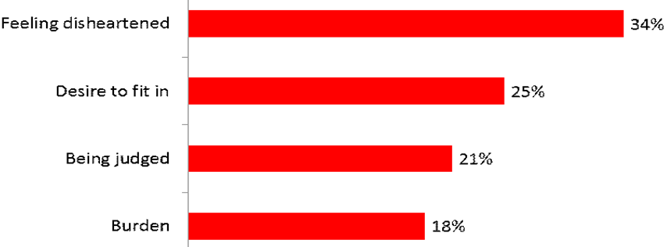
- Feeling disheartened / lacking confidence
Identified as a barrier by over 3 in 10 (34 percent)

One of the main concerns for supporters is if something goes wrong during an activity. What impact will that have on the disabled person they support? What impact will that have on them as a supporter? What type of support would they need to give to help the disabled people overcome the upset that may occur?

“He went to basketball once. Once he got there he felt undermined, no-one would pass him the ball.” Supporter of someone with physical impairment

“He enjoys it for a while until something goes wrong, and then I can’t get him to go back.” Supporter of someone with a behavioural condition

“He can get easily discouraged if it’s not working out well and he’s not enjoying it. He won’t push himself, so he might just sit and refuse to join in.” Supporter of someone with a learning disability

“She can get very disheartened and disappointed when things don’t go right. She wanted to take part in baby yoga and has been told that she can’t due to lack of insurance, she’s been very upset about that” Supporter of someone with a visual impairment

If the activity is too difficult or the experience does not match up to expectations the disabled person will feel disheartened. It could have taken a long time to encourage the person to take part and if they have a negative experience they may refuse to try again.

Expectations are constantly being managed which results in supporters looking for social activities rather than competitive elements to minimise the risk of a bad experience.

- Desire to fit in
Identified as a barrier by 1 in 4 (25 percent)

Disabled people do not want to stand out or feel ‘different’ and often don’t want to be labelled as disabled or grouped with other disabled people. Therefore they often don’t want to participate in disabled people only activities

“He’d want to know that others [non-disabled people] were going to be there” Supporter of someone with a physical impairment

“She really wants to do things, but feels like she can’t. If she isn’t doing it a certain way she can feel told off, and will get upset” Supporter of someone with learning disabilities and physical impairment

Those whose impairments are ‘invisible’ such as hearing loss can feel very isolated during sports and activities as they can easily be misunderstood. If an impairment is not obvious to other participants, staff and the general public then this can often lead to the disabled person and supporters feeling isolated and lonely.

A sense of frustration can also come along with this. If the impairment is not immediately obvious, particular needs are not always understood or met and as such both the supporter and the disabled person can feel frustrated and ignored.

“I would say he has an ‘invisible’ disability. People can bully him because they don’t understand, so he prefers to be around family” Supporter of someone with learning disabilities

“He’s not very good at communicating because of his hearing, but it’s those disabilities that other people don’t realise when they are trying to talk to him” Professional Supporter

- Being judged
Identified as a barrier by 2 in 10 (21 percent)

Some supporters, particularly those supporting people with learning disabilities or behavioural issues, are concerned that they themselves or the disabled person they support might be judged due to their behaviour or even just due to the way they look.

This is more common among parents who are concerned other people associate their child’s behaviour to bad parenting rather than their impairment. Professional supporters are also often concerned about people’s reaction when there is a need for them to be physical with the disabled person, particularly if they are looking after children.

“I worry that he might be judged or harassed yes, if he says something that’s odd or random. People might call him a freak or something. He doesn’t understand idioms so while we might say strange things like ‘pick your brain’, he thinks you can make those up yourself – he made one up the other day and everyone called him a weirdo for it. So yes I do get nervous about that” Supporter of someone with behavioural issues

- Feeling like a burden
Identified as a barrier by almost 2 in 10(18 percent)

It is quite common for disabled adults to feel that they do not want to be a burden on their supporters. Adults with acquired impairments are particularly conscious of the impact that their support needs have on family and friends. This can lead to disabled people ruling out particular activities where they know they will need a lot of assistance

“I feel like she does want to do sport. She wants to do it but she just feels like she can’t. I don’t know what it is. She doesn’t want to be a burden to other people.” Supporter of someone with physical impairment

Conclusion
Supporters are aware of the benefits of disabled people being active. However, they feel there are a number of barriers which prevents them from being as active as they would like to be.

If a supporter is personally more active, they are more likely to work harder to help the disabled person overcome these barriers. However, for all supporters, providing more information and support to reduce some of the barriers would be a great way to build their confidence about an activity’s suitability.

Section 5: What a supporter needs to know about an activity

When helping disabled people make a decision about new activities there are a number of considerations that supporters take into account to determine the suitability of that activity.

Figure 7: The 5 areas a supporter considers when finding out if an activity is suitable
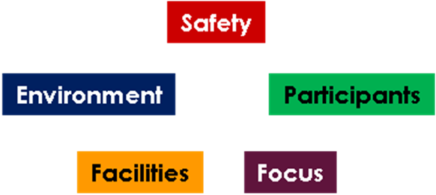

All of these considerations help them to determine the relevance of the activity to the disabled person. The supporter tries to assess whether the activity is something the disabled person will be able to do and enjoy.

- Environment
In total 8 in 10 (78 per cent) of supporters indicated that they needed to know some level of information about the environment the activity would take place in. The types of questions they have include:
- How busy will the activity be?
  - How many other people will be there?
  - How much noise is there?
  - What age ranges are included?
  - Does the activity cater for disabled and non-disabled people?
- What is the focus of the venue?
  - Is it aimed at having fun and learning new skills or at development of the actual sport?
  - Can the disabled person go at their own pace?
  - Will the supporter be able to intervene if the person they support starts to act unpredictably?
- How many staff will be present and what is their attitude like?
  - Are they supportive to people who have additional needs?
  - This concern was more prevalent for parents
- How long will the activity take?

- Facilities
7 in 10 (68 per cent) supporters have questions about the facilities

Things that supporters look for in facilities include:
- The location and local transport links
- The accessibility
  - Is it wheelchair friendly e.g. automatic doors?
  - Does it have adaptable facilities?
  - Does it have suitable changing rooms and bathroom facilities?
- What potential hazards exist?
- Familiarity of the venue
  - Do they have links with the venue already (e.g. local school or village hall)?
  - Do they know the people who use the venue (e.g. local faith centre)?

The questions and concerns supporters have about facilities will differ depending on the impairment of the person they support.

For the majority of the supporters, the location of the facilities is the most important consideration. People generally look for activities in venues close to home. Somewhere the disabled person is familiar and comfortable with.

- Safety
5 in 10 (48 per cent) supporters have questions around safety.

The safety of the disabled person they support is a significant concern for supporters. Supporters are mindful that injury at an activity could cause both physical and emotional setbacks.

This does not just cover the physical safety of a participant but also the psychological safety. Will taking part be a pleasant and enjoyable experience for the disabled person? Or will it be a negative and potentially emotionally damaging experience that the supporter will then have to manage and overcome afterwards?

Safety is a slightly greater concern for professional carers as they have to conduct a full risk assessment before attending new activities to determine the suitability of that activity.

The safety of others is also a concern. Will the disabled person taking part impact the experience of others? Negative reactions from other participants can have significant repercussions and make supporters less willing to try new things. These concerns are more prevalent for people who support people with a learning disability or behavioural conditions.

Safety concerns, whilst still important, seem less of a concern to parents than to other supporter types.

- Focus of activity
3 in 10 (34 per cent) supporters seek information about this.

Will the activity be fun or competitive? This is linked strongly to confidence. Can the supporter be confident that the disabled person they support will have an enjoyable time and want to return, so that the time and effort invested in getting them to the activity was worthwhile?

Very few people said that a competitive focus was appropriate. Activities should be fun and focus on achieving targets, perhaps individual, rather than participation in competition.

Parents are much more likely to seek out activities which are fun. They fear competition will not be fair or equal and lead to their children having bad experiences.

- Participant type
3 in 10 (30 per cent) have questions around this.

Supporters are keen to understand the other people who will be taking part
- Does it cater for disabled people only or a mix of disabled and non-disabled?
- Who else will be there? E.g. Male, female
- How old will they be?

Conclusion
There are a multitude of questions supporters can have about an activity to determine its suitability. As more of these questions are answered the more confident supporters can become that an activity is suitable and the more likely they will be to recommend it to the disabled person they support.

It is therefore important that supporters can easily access as much information relevant to their questions as possible, with minimal effort.

Section 6: How to communicate the information to supporters

The research has shown the supporters play a key role in helping disabled people to be active. So communicating opportunities directly to them can be a good way to increase awareness of opportunities.

When developing communications for supporters there are four main areas to consider:
- The imagery used
- The language used
- Stories giving examples
- Contact information

The guidance in this section is a generalisation of the results of the research and does not apply to all supporters.

Imagery
Imagery is the first thing that people see so should be bright and bold to grab attention. Previous research showed that disabled people prefer photographs of actual people in the imagery, whereas supporters find iconography and illustration appealing too.

The two main things supporters take away from the imagery is how intense an activity will be and if it is clear that the activity is suitable for disabled people.

If imagery depicts an activity as something which is intense, competitive and professional it makes the majority of supporters think it is unsuitable and out of reach of the disabled person they support.

Figure 8: Examples of images supporters felt portrayed ‘intense’ activity
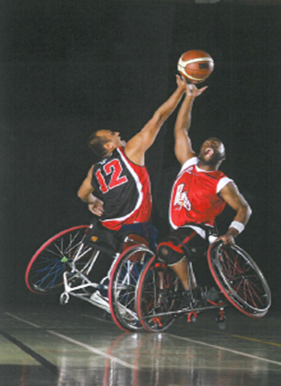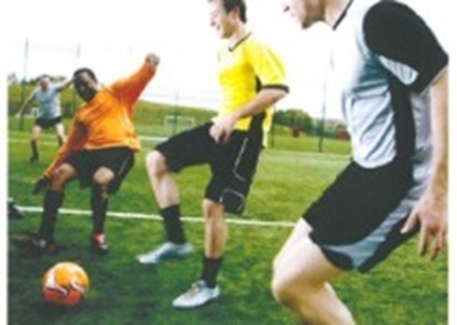
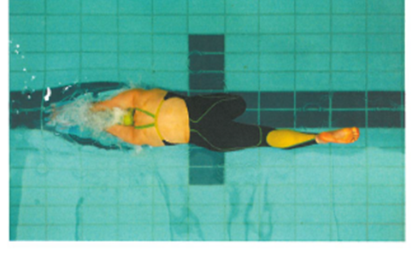

There is a preference for imagery which depicts sport and physical activity as something which is low intensity and achievable. This is particularly prevalent among parents and guardians.

Figure 9: Examples of images supporters felt portrayed ‘low intensity’ activity
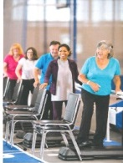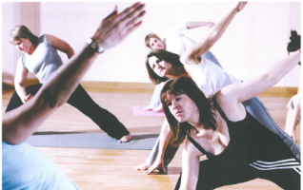

Previous research has shown that disabled people themselves generally prefer images which do not overtly depict disability but show people enjoying the activity and having fun. This research shows that different type of supporters have different reactions to images that show overtly disabled people.

Professional carers find overt images more appealing. This is because they need to be able to quickly digest and assess information and determine whether an activity is suitable. Professional carers are also generally less emotionally involved with the people they support and therefore less worried about how the disabled person themselves would like to be portrayed.

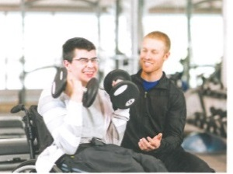
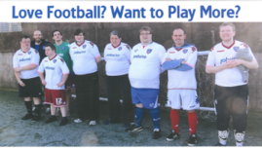
Figure 10: Examples of images supporters felt were overtly showing that the activity was suitable for disabled people

Parents and guardians are more likely to prefer subtle imagery or imagery of non-disabled people. Friends and family are most likely to prefer subtle imagery.

Figure 11: Examples of images supporters felt were subtly showing the activity was suitable for disabled people
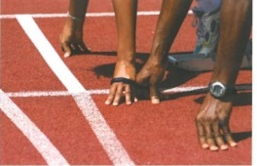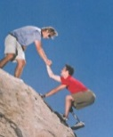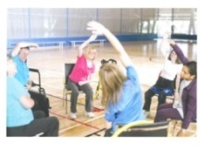

Subtle imagery gives supporters the impression that the disabled people will be offered support whilst taking part.

In addition to intensity and overt images of disabled people, supporters use the imagery for subtle clues to match their goals and ideas of what makes a suitable activity, such as:
- That people who participate enjoy the activity
- What ages take part
- Who the activity is suitable for in terms of impairment
  - This is more challenging for people with less visible impairments such as hearing impairment or when trying to convey suitability for multiple impairments
  - Supporters of people with learning disabilities often find overt imagery patronising. They said that the people they support do not identify with these images.
- Whether support to help the disabled person to be active is included

Language
Sport and physical activity providers often use the term ‘inclusive’ to describe an activity that is suitable for both disabled and non-disabled people. However the research is showing that by itself the word portrays an inconsistent message. Supporters can often be unclear what inclusive means, especially non-professional carers.

To ensure that the message about what inclusive means is correctly interpreted imagery should be used alongside the wording to help explain the meaning.

Aligned with research from disabled people, some supporters, such as parents and friends often state that they dislike the use of disability in the title of activities. However, for other supporters, especially professional carers, the use of disability helps them make quick decisions about whether an activity is suitable.

Stories
Whilst not essential, supporters do like to be able to read stories and reviews from disabled people who currently or have previously taken part in the activity. This gives the supporter confidence that the activity is suitable for disabled people.

These stories should focus on overcoming some of the concerns supporters have about disabled people being active, highlighting activities that are safe, the environment is friendly and welcoming and that disabled people have fun.

Feedback and reviews from other supporters can also be useful. Especially emphasising the benefits that they themselves can get from the disabled person taking part, such as a support network, or respite from daily support.

Key contact
Providing contact details of someone the supporter can get hold of to ask questions is a great way to build confidence. This allows them to seek clarification on anything they are uncertain about.

Section 7: How supporters seek information

Supporters use a number of different sources of information to find out about activities. The types of source used can vary slightly by supporter type. Generally however their search is focused around location, things which are nearby and easier to get to

Professional carers are generally more confident in searching for activities. They have more experience in what to look for and the types of questions to ask providers to help determine whether an activity will be relevant suitable and safe.

Online searches
General internet searches are the most popular ways in which supporters seek new information. However, 3 in 10 supporters (34 per cent) are unsure what terms to input into a search engine to identify sport and physical activity sessions.

Figure 12: Chart showing the different terms people type into internet searches
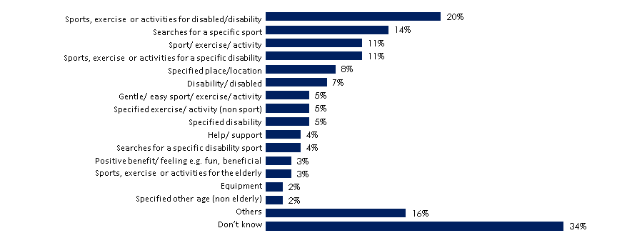

When terms are used, the most common term is sports, exercise or activities for disabled people / disability. After that it is a search for a specific sport or exercise, or just sport and exercise in general.

Using the impairment type and looking for sport for a specific impairment is only used by 8 per cent of supporters. This suggests that they primarily do not look for impairment specific activities or do not know about them.

Network / word of mouth
Word of mouth, generally from trusted sources (friends, other supporters, peers) is a very influential information source. This is because supporters trust the information from their networks as they are made up of people who understand their needs and requirements.

Word of mouth is particularly influential among professional carers. Professional carers are more likely to have a wider network of people who are exposed to information about activities and who are more able and willing to make judgements on suitability of those activities. Whereas friends and family may have access to smaller networks, containing people with less knowledge about sport and physical activity opportunities.

Local facilities
Local facilities, such as sport centres, youth clubs, village halls or faith centres, are a common place for supporters to seek information. They are an obvious starting point as this is where activities often take place. Information is usually sought from websites, unless they already have some contact within the facility.

Whilst facilities can be a popular choice as a starting point, supporters are often frustrated as they find information not readily available and there is sometimes a sense of fear from facilities about offering activities for disabled people.

Disability specific organisations
Supporters seek information from disability organisations, both local and national. They are more confident that such organisations will understand the needs and the requirements of the disabled people. Therefore any suggested activity will be in a suitable environment with adequate safety and support.

Local charities and special needs schools
As with disability organisations, local charities and special needs schools are seen as places who have more understanding of disabled people’s needs. In addition they are based in the local area, so seen as a good information source in helping to identify opportunities in the near vicinity.

Making links to local organisations also offers the supporters the chance to build up a support network of people who understand their needs.

Conclusion
Targeting supporters with communications about activities for disabled people is another way of encouraging disabled people to be active.

In communications material, consideration needs to be given to using imagery, words and information that will appeal to supporters

Some supporters’ negative perceptions need to be overcome if more disabled people are to become involved in competitive sport.

Sports providers should encourage supporters of disabled people who do participate in sport to spread the word to other supporters that they are in contact with.

Conclusion

Supporters clearly have an important role to play in encouraging and supporting disabled people to be active.

Providers need to ensure the relevant information is available for supporters which help them to overcome their concerns and be more confident that an activity is relevant and suitable for the disabled people they support.

Different communication types are beneficial in engaging a wide range of supporters, so providers need to better understand the type of supporter e.g. family or professional, they want to target, as well as disabled people and adapt their communications accordingly.

For more information on this survey or report, please contact Emma Spring at EFDS.
Email espring@efds.co.uk or telephone 0161 2005442
The report is available to download on www.efds.co.uk
Twitter @Eng_Dis_Sport

Join our insight panel
EFDS is always looking for disabled people’s support on our insight projects. There are many occasions we may get asked to help with other organisations’ research or for our own development plans.
If you would like to join our panel of disabled people, please contact us on research@efds.co.uk or 0161 200 5442. It will be mainly communication via email or telephone, so you do not have to commit to any unnecessary time or travel.

Motivate Me, EFDS May 2014
Talk to Me, EFDS, May 2014

