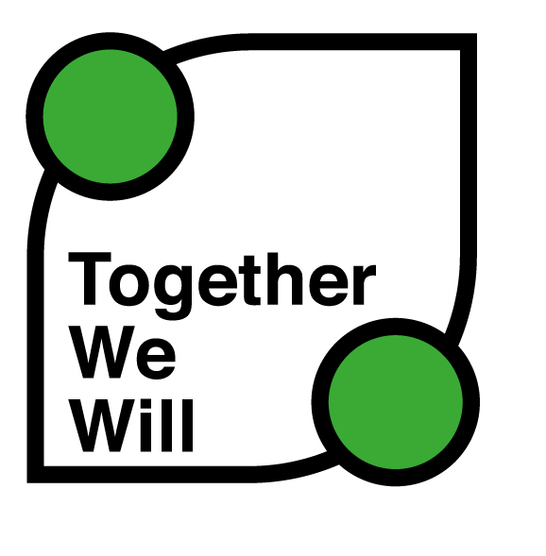

Frequently asked questions about being active

This document provides you with useful information about the benefits of being active and how you can get started.

- Why should I be more active?
- Being active will improve your health and wellbeing both physically and mentally.
- Being active also has enormous social benefits, getting you out and about and meeting new people.
- Whatever your impairment or health condition, becoming more active can only make you fitter and healthier.
- You may feel tired after exercising, but in the long term it will give you more energy.
- Regular exercise can help you with everyday activities. It can boost memory, reduce stress and improve sleep.
- Consider exercising outside and with other people. Experts say that’s the perfect combination.
- Try 20 minutes of exercise a day, enough to make you sweat. That’s two hours 30 minutes a week.
- How hard should you exercise? Enough to make you too breathless to sing but not to talk.

- How do I get more active?
- Talk to healthcare professionals to work out which activities best suit you.
- Start slowly and build up – exercise is no quick fix. Don’t do more today than you can manage tomorrow.
- Pick an activity you enjoy. It needn’t be sport, just something that gets you moving and your heart pumping.
- Try to think of activities that work your heart and help flexibility, strength, co-ordination and balance.
- Don’t fear going along and getting involved – more and more places are becoming accessible.
- Providers can not use health and safety as an excuse – the law allows disabled people to make our own choices about what we want to try.
- If you want to try a sport or use a facility you have a right to ask, and to expect people to make “reasonable adjustments” to accommodate you.

- What if I don’t feel confident enough?
- There are lots of excuses out there – all of them will keep you inactive.
- Who cares what you look like? Do what you enjoy, or try something you never have before.
- Think of different ways of exercising. There are many exercises you can do at home with no or cheap equipment.
- Try to build exercise into your daily life. Take the stairs, walk to the shops, exercise while watching the TV.
- Exercises DVDs are very popular, and lots of exercises require no equipment at all.
- Low-impact exercise minimises the chance of injury. Yoga, Tai Chi and Pilates are great for improving muscle strength, tone and balance.
- How about walking? You don’t need to get changed or warm up, and it can be incorporated into your daily life.
- How about cycling? A great form of transport, there are more cycling routes and lanes than ever before.
- How about running? Start slowly then slowly get faster, and you don’t need to run every day.
- How about the gym? Find an accessible gym full of accessible facilities, equipment and well-trained staff.
- How about swimming? One of the safest ways to exercise, being in the water maximises the benefit you get from your movements.
- There are loads of accessible sports out there. Try a few and find the one you most enjoy.

- Where can I find out more?
- Your local library, leisure centre or council social services will have plenty of useful information.
- Contact English Federation of Disability Sport (EFDS): www.efds.co.uk
- Get in touch with your local County Sports Partnership (CSP): www.cspnetwork.org/your-csp

- Contact the National Disability Sports Organisations (NDSOs)
There are eight NDSOs that provide people of all ages with specific impairments opportunities to be more active and enjoy taking part in sport and exercise.
They are:
British Blind Sport: www.britishblindsport.org.uk
Cerebral Palsy Sport: www.cpsport.org
Dwarf Sports Association UK: www.dsauk.org
LimbPower: www.limbpower.com
Mencap: www.mencap.org.uk
Special Olympics Great Britain: www.specialolympicsgb.org.uk
UK Deaf Sport: www.ukdeafsport.org.uk
WheelPower: www.wheelpower.org.uk

Together We Will is brought to you by the National Disability Sports Organisations in partnership with EFDS and is supported by Sport England.

