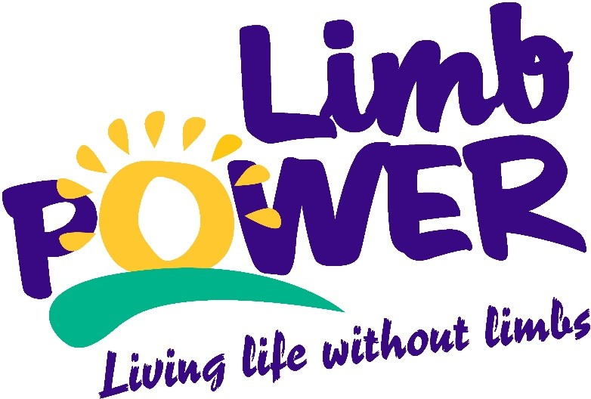

Amputee Sport and
Physical Activity Survey
2016

www.limbpower.com

Contents

Background 3
About LimbPower 3
What we do 3
Why we do it 3
Foreword 4
Sample information 5
Who we spoke to 5
Impairment information 5
Assistive technology 6
Prosthetic use 6
Sport and physical activity participation 6
Sports and activities 6
Motivations and barriers 7
Future participation 8
Latent demand 8
Sports and activities 8
Preferred sport formats 9
LimbPower contact details 10

Background

About LimbPower
Established in 2009, LimbPower supports amputees and individuals with limb impairments to reach their full potential.
Our mission is to engage people with limb impairments in regular participation in physical activity, sports and the arts, to improve their quality of life and aid lifelong rehabilitation. In 2014, the charity was formally recognised as a National Disability Sports Organisation by the English Federation of Disability Sport.

What we do
LimbPower aims to support amputees and people with limb impairments to find a sport or leisure activity they enjoy and is suited to their needs and ability. We run a number of national and local physical activity and sport events, and workshops each year to provide individuals with participation opportunities and support them on their personal journey to being more active. Whether they are keen to try something new, or wanting to get back into a much loved activity post amputation.
LimbPower also uses its expertise, experience and partnerships to promote local inclusion of people with limb impairments in sport and physical activity opportunities. We provide expert knowledge to disabled people, family members, healthcare professionals, sports providers and education professionals about how better engage people with limb impairments and adapt activities to meet their needs.

Why we do it
At LimbPower, we know that losing the use of a limb can be a traumatic experience at any age, and that trying to engage in activity can be daunting. We also know about the positive impact that being physically active can have on a person’s physical, mental and social wellbeing. Our events and programmes are designed to provide a safe, friendly and supportive environment for amputees and people with limb impairments to enjoy taking part in sport, physical activity and the arts.
For more information, please visit www.limbpower.com.

Foreword
Kiera Roche, Chief Executive Officer, LimbPower
LimbPower embarked on this research to better understand the motivations and barriers to participation in physical activity and sport amongst people who have undergone an amputation or were born with a limb impairment. With a specific focus on the role of prosthetic sockets and prosthetic components when taking part in sport or being physically active. We spoke to 249 amputees and people with limb impairments as part of this research.
Our primary objective for this research was to identify and better understand people’s motivations and barriers to activity. As a result, we aim to adapt and develop LimbPower’s events and programmes so they continue to meet the needs of people with limb impairments. Also, to provide participants with the right support on their journey to being more active.
As we expected, the most common barriers to taking part in physical activity and sport were the limitations of their prostheses and poor socket fit or comfort. These findings highlight a need for further investigation into the role that prostheses and sockets can have on a person’s engagement in sport and physical activity. Moving forward, LimbPower will use the results from this survey to produce a separate report, examining in detail the impact of using prostheses for sport and physical activity.
Despite these barriers, more people than anticipated (36%) own a prosthesis specifically for sport use. However, it is important to note that the sample surveyed in this research was an active one.
Over 8 in 10 respondents (83%) would like to take part in more sport and physical activity in the future. The most common motivations for taking part in sport and physical activity are enjoyment, and to keep fit and healthy. This is incredibly encouraging as keeping fit and healthy has many positive physical and psychological health benefits for people with limb impairments. It also plays an important role in socket fit and socket comfort.
In line with other research into the sport and physical activity participation of disabled people, the most popular current activities are swimming, walking, cycling and going to the gym. Going forward we will look to focus more LimbPower events, workshops and resources on these core activities to encourage more regular and sustained participation among the amputee community. It is also important to look at how we can incorporate new activities that respondents are interested in taking up into our programmes, including archery, canoeing/kayaking and running.
Overall these survey results reinforce the importance of our work and provide us with a clearer understanding about people’s attitudes towards sport and physical activity. LimbPower will use this insight to work with and advise key providers on how they can deliver more appealing and suitable physical activity and sport opportunities for amputees and people with limb impairments.

Sample information

Who we spoke to
- 249 people with an amputation of limb impairment.
- 62 per cent of respondents were male.
- 38 per cent of respondents were female.
- The mean age of respondents was 48 years old.
Regional location breakdown of the sample across United Kingdom was as follows:
- 11 per cent East region
- 14 per cent East Midlands region
- 11 per cent London region
- 3 per cent North East region
- 12 per cent North West region
- 1 per cent Northern Ireland
- 4 per cent Scotland
- 22 per cent South East region
- 10 per cent South West region
- 2 per cent Wales
- 7 per cent West Midlands region
- 5 per cent Yorkshire and Humber region

Impairment information
Sample breakdown of type of amputation or limb impairment:
- 46 per cent below-knee
- 9 per cent through-knee
- 24 per cent above-knee
- 8 per cent upper body
- 8 per cent multiple amputations or limb impairment
- 5 per cent other form of amputation or limb impairment
Sample breakdown of cause of amputation or limb impairment:
- 51 per cent accident or trauma
- 10 per cent peripheral vascular disorder
- 8 per cent congenital
- 7 per cent diabetes
- 5 per cent cancer
- 18 per cent other

Assistive technology

Prosthetic use
79 per cent of respondents are currently using a prosthesis as part of daily life.
- 58 per cent of prosthetic users own more than one prosthesis
- Average duration of prosthetic use is 13 years and 7 months
- All prosthetics are supplied through the NHS for 87 per cent of prosthetic users
- Over one third (36 per cent) of prosthetic users surveyed have at least one prosthesis that is specifically for sport use
- 53 per cent of respondents use crutches in some situations
- 57 per cent of respondents use a wheelchair is some situations
- 21 per cent of respondents use or orthesis

Sport and physical activity participation

Nearly 8 in 10 people surveyed (78 per cent) have taken part in exercise, physical activities or sport in the last 12 months.
Groups of respondents most likely to participate in sport and physical activity include:
- Younger people, aged 36 years and under (89 per cent)
- Above-knee amputees (85 per cent)
- Those who have been using a prosthesis for 3-10 years (86 per cent)
- Those who have a prosthesis that is specifically designed for sport use (92 per cent)

Sports and activities
The top ten most popular current sports and activities are:
- Swimming - 35 per cent of all respondents
- Walking - 33 per cent of all respondents
- Cycling - 29 per cent of all respondents
- Gym - 28 per cent of all respondents
- Fitness classes - 14 per cent of all respondents
- Weightlifting - 12 per cent of all respondents
- Golf - 10 per cent of all respondents
- Running - 10 per cent of all respondents
- Shooting - 9 per cent of all respondents
- Wheelchair basketball - 8 per cent of all respondents
The table below shows additional information around the frequency of current participation, future intention to participate and use of prosthetics within each of the top five current activities.
Activity | Frequent participation: people taking part in sport once a week or more | Future participation: people intending to take part more in the next 12 months | People currently using a prosthesis when taking part in activities (always or sometimes)
Swimming | 59% | 32% | 27%
Walking | 93% | 39% | 99%
Cycling | 66% | 48% | 90%
Gym | 88% | 33% | 94%
Fitness classes | 74% | 15% | 87%

Motivations and barriers

The top five motivations to take part in physical activity and sport are:
- Enjoyment and fun (67 per cent of all respondents)
- To keep fit (61 per cent of all respondents)
- To improve health (56 per cent of all respondents)
- This was especially common amongst older people and those who are currently inactive.
- To relax and de-stress (43 per cent of all respondents)
- To socialise (40 per cent of all respondents)
- This was more common for older people with limb impairments.
Increasing confidence and self-esteem was one of the top five motivations for middle aged (36-54 years old) respondents.
Competition and improving their skills/performance ranked as highly motivating for younger people, aged 36 and under.
The top five barriers to taking part in physical activity and sport are:
- Prosthetics limitations (28 per cent of all respondents)
- Socket fit or comfort (22 per cent of all respondents)
- Lack of fitness (19 per cent of all respondents)
- This was particularly common amongst older people and those who are currently inactive.

- Lack of facility support (18 per cent of all respondents)
- This was most common among female respondents and people aged 36-54.
- Fear of falling (17 per cent of all respondents)
Other health conditions, fear of injury and not knowing how to find out about suitable opportunities, were among the top five barriers for inactive respondents.
Fear of injury and other health conditions were among the top five barriers for older respondents.

Future participation

Latent demand
Over 8 in 10 respondents (83 per cent) are interested in doing more sport or physical activity in the future.
Groups of respondents most likely to be interested in taking part in more sport of physical activity in the future are:
- Females (92 per cent)
- Above-knee amputees (90 per cent)
- Those who have started using a prosthesis in the last two years (95 per cent)

Sports and activities
The top ten sports and activities people are interested in taking up or doing more of in the future are:
- Archery - 18 per cent of all respondents
- Cycling - 18 per cent of all respondents
- Swimming - 17 per cent of all respondents
- Canoeing/kayaking - 17 per cent of all respondents
- Running - 16 per cent of all respondents
- Gym - 16 per cent of all respondents
- Snowsports - 15 per cent of all respondents
- Dancing - 15 per cent of all respondents
- Climbing - 13 per cent of all respondents
- Fitness classes - 13 per cent of all respondents

Preferred sport formats

A number of alternative formats of traditional sports have been developed for amputees and other disabled people e.g. amputee football and wheelchair basketball.
The table below show respondents preferred formats for taking part in six popular sports.
Sport | Preferred format of those interested in the activity
 | Ambulant with a prosthesis | Ambulant without a prosthesis | In a wheelchair | On crutches
Basketball | 47% | 14% | 37% | 2%
Cricket | 78% | 10% | 11% | 1%
Football | 61% | 17% | 7% | 15%
Hockey | 65% | 15% | 18% | 2%
Rugby | 50% | 13% | 32% | 5%
Tennis | 55% | 12% | 29% | 4%

LimbPower contact details

LimbPower
Whitecroft
Tandridge Lane
Lingfield
Surrey
RH7 6LL

Telephone: 07502 276858
Email: info@limbpower.com
Twitter: @LimbPower
Facebook: LimbPower
Website: www.limbpower.com

Registered Charity Number: 1132829

