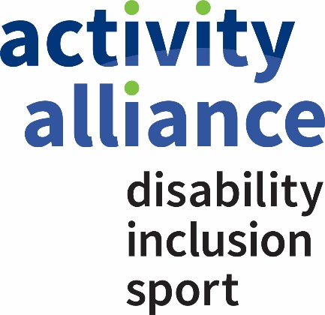
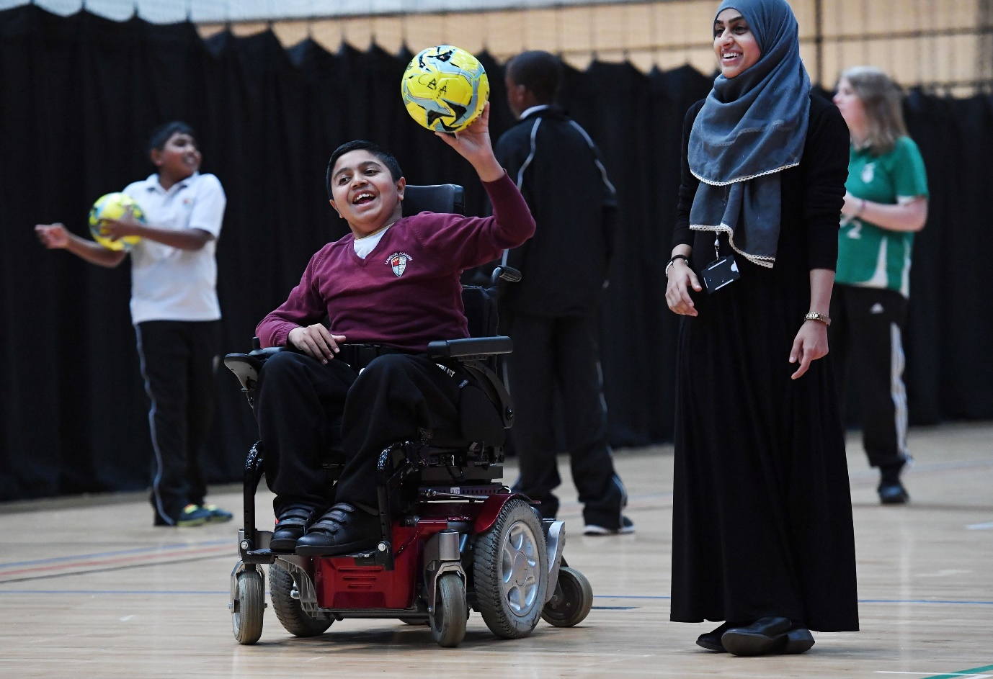

Activity Alliance

Diversity Action Plan

[2019-20XX]
Reviewed and approved by Board on 28 February 2019

Contents
About Us 3
Our Mission 4
Our Vision 4
Our Values 4
Message from Our Chair 5
Strategy 6
Key Questions 15

About Us

In 2018 English Federation of Disability Sport became Activity Alliance to further strengthen our Mission to bring our members, partners and disabled people together to make active lives possible. In September 2018, we celebrated 20 years since we became a national charity and we are proud of our success so far.
One of the key developments in the structure and organisation of disability sport was the creation of the English Federation of Disability Sport in 1998. The English Federation of Disability Sport was developed in response to the outcomes of a National Disability Sports Conference, and further wide-ranging consultations. It was formed to provide a more coordinated approach to the planning and provision of sport for disabled people.
Activity Alliance works in partnership and co-operation with a range of organisations including NGBs and NDSOs to plan, develop and deliver sustainable sport, physical activity and recreation programmes/opportunities for disabled people at local, regional national and international level.
Activity Alliance has offices in Loughborough and in Manchester. Activity Alliance is member based. It has two categories of members – Full Voting Members and Associate Members.

Our Mission
“Making active lives possible” by enabling organisations to support individual disabled people to be active and stay active for life.

Our Vision
“Disabled people are active for life”
This vision is our view of the future position that we wish to see achieved. Our definition of that position is that equality in participation whereby disabled people are just as likely to be active as non-disabled people. Our clear target for progress by March 2021 is to see disabled people’s participation rates on a sustainable upward trajectory. Disabled people remain the least active group in the society and organisations continue to need the help of Activity Alliance and our Member and partner organisations to enable them to respond effectively to this challenge.

Our Values
New text: We continue to strengthen and embed a dynamic organisational culture built solidly on the shared values of our staff, volunteers, members and partners.
- We are motivated by seeing the real change that we help to make possible.
- Our shared values shape our behaviour. At Activity Alliance we:
  - are passionate about unlocking the life-changing value of sport and active recreation
  - embrace family values, placing loyalty and empathy at the heart of what we do
  - build relationships on trust, honesty and openness
  - are guided by disabled people and a determination to achieve equality

Message from Our Chair
I am proud to be Chair of Activity Alliance whose strong commitment to strengthening its diversity, equality and inclusion sits at the heart of what we do and aim to achieve as an organisation. Here at Activity Alliance we understand, prioritise and embrace the importance of diversity and inclusion, which is a crucial factor for the success of our organisation. Therefore, we recognise that Activity Alliance’s Board should be fully reflective of the wider community Activity Alliance serves by being appropriately representative of disabled people and applying the equality principles as set out in the Equality Act 2010.
We will ensure that the voice of disabled people is well represented by the Board of Trustees by ensuring that our Board contains a diverse mix of talented directors to exercise strong decision-making to help achieve our vision of “making active lives possible by enabling organisations to support individual disabled people to be active and stay active for life”.
The Board have set a target of parity between the number of male and female Trustees and will take all appropriate actions to maintain that position.
We will ensure that the Board of Trustees will demonstrate a strong and public commitment to progressing towards achieving gender parity and greater diversity generally on its Board of Trustees, including Black Asian and Minority Ethnic (BAME) diversity, sexuality and gender. As an organisation focused on sport and active recreation for disabled people we will, in particular, aim to ensure full representation, engagement and influence of disabled people at all levels of the organisation.
Activity Alliance is committed to ensuring it is both fully supportive of, and compliant with, all relevant national and international laws, rules, regulations and standards relating to both equality and diversity in relation to Activity Alliance’ Board of Trustees but also throughout the Company. We are committed to the adoption of appropriate standards such as the Equality Standard for Sport and to progressing to an appropriate level of achievement.
We will continue to aspire to meet and exceed standards of good practice. We need to work together across various sectors to ensure all disabled people can be active wherever and however they want to be. Our expanding membership and growing network of partners will certainly help us to achieve this in the coming years. Together we really do make a difference. Despite the tangible progress and a positive outlook, we work in the knowledge that disabled people remain the least active group in our population.

Strategy
Strategic Area 1 - Recruitment
Recruitment  How the organisation will attract an increasingly diverse range of candidates |  | Code for Sports Governance
 |  | Adopt a target of, and take all appropriate actions to encourage, a minimum of 30% of each gender on its board | Demonstrate a strong and public commitment to progressing towards gender parity and greater diversity generally on its board | Demonstrate a strong and public commitment to progressing towards achieving greater diversity generally(including but not limited to BAME, disability, LGB&T and socio-economic) |  | Each organisation shall identify proportionate and appropriate actions to be taken to support and/or maintain (as appropriate) the diversity targets set out in Req 2.1 | The board shall ensure that the organisation prepared and publish on its website information (approved by the Board) about its work to foster all aspects of diversity with its leadership and decision making) | The board shall ensure the organisation prepared and publishes on its website information (approved by the Board) including an annual update on progress against actions identified in Req 2.2
Objective: Embed good diversity and inclusion practice into our recruitment activities and decision making processes |  | x | x | x |  | x | x | x
Priorities | Actions |  |  |  | Person(s) Responsible |  |  |  | Completion Date
Short Term:  1. To review the current Board equality breakdown at Activity Alliance.  2. To promote Activity Alliance’s commitment to equality through publishing the Activity Alliance Equality, Equity and Diversity policy statement with accompanying action plan on our website.  3. To attract a broad applicant base when recruiting for new board positions  4. Demonstrate a strong and public commitment to progressing towards achieving gender parity and greater diversity generally on its Board, including, but not limited to, Black, Asian, minority ethnic (BAME) diversity, and disability. | 1.1. Carry out a board and staff equality survey  1.2. To feedback results of equality board survey to Activity Alliance board  1.3. To publish the results of annual board and staff equality survey on Activity Alliance website  1.4. To use results to understand the gaps within the Activity Alliance board relating to gender balance, BAME, Disability and other areas set out in Activity Alliance Equality Policy statement.  2.1. Policy to be approved/reviewed by board  2.2. Policy to be published on Activity Alliance website  2.3. Policy to be reviewed annually  3.1. Use Activity Alliance Equality, Equity and Diversity statement on all recruitment materials  3.2. Advertise Board positions through stakeholders as identified in Stakeholder consultation policy.  3.3. Target both BAME and female communities through working with organisations such as Sporting Equals, Women in Sport and specific faith organisations.  3.4. Advertise board positions using appropriate print, internet and social media  3.5. Capture equality and diversity information on Board Member applicants. Feed this back to Nominations committee to analyse the success of the marketing.  4.1. To promote Activity Alliance’s commitment to equality through reviewing annually and publishing the Activity Alliance Equality, Equity and Diversity policy statement with accompanying action plan on our website. |  |  |  | Nominations Committee  Nominations Committee  Marketing and Communications Manager  Nominations Committee  Board  Marketing and Communications Manager  Board  Nominations Committee  Nominations Committee  Nominations Committee  Marketing and Communications Manager, Nominations Committee  Marketing and Communications Manager/recruitment agency  and Nominations Committee  Board, Marketing and Communications Manager |  |  |  | 31 March 2019  31 July 2019  31 July 2019  31 July 2019  5 December 2019  31 January 2020  November-December annually  When recruiting  When recruiting  When recruiting  When recruiting  On completion of recruitment process  November annually
Medium Term:  1. Introduce a Young Persons Forum to ensure our work creates opportunities for their voice to be heard in planning and delivery of opportunities and activities. | 1.1. To create initial terms of reference  1.2. To recruit appropriate disabled candidates from a variety of protected characteristic groups |  |  |  | Equality and Diversity Champions  Equality and Diversity Champions |  |  |  | April 2020  November 2020
Long Term:  1. Demonstrate a strong and public commitment to progressing towards achieving gender parity and greater diversity generally on its Board, including, but not limited to, Black, Asian, minority ethnic (BAME) diversity, and disability.  2. To recruit Board that is reflective of a diverse community it serves. | 1.1. To review the policy annually  2.1. To monitor Board make-up in the future  2.2. To analyse Board skills against the strategic objectives of the organisation. |  |  |  | Board  Nominations Committee  Nominations Committee |  |  |  | November/December Annually  November Annually  November  Annually
Strategic Area 2 - Engagement
Engagement:  Ensuring that your organisation’s commitment to diversity is communicated through internal practices and externally |  | Code for Sports Governance
 |  | Adopt a target of, and take all appropriate actions to encourage, a minimum of 30% of each gender on its board | Demonstrate a strong and public commitment to progressing towards gender parity and greater diversity generally on its board | Demonstrate a strong and public commitment to progressing towards achieving greater diversity generally(including but not limited to BAME, disability, LGB&T and socio-economic) |  | Each organisation shall identify proportionate and appropriate actions to be taken to support and/or maintain (as appropriate) the diversity targets set out in Req 2.1 | The board shall ensure that the organisation prepared and publish on its website information (approved by the Board) about its work to foster all aspects of diversity with its leadership and decision making) |  | The board shall ensure the organisation prepared and publishes on its website information (approved by the Board) including an annual update on progress against actions identified in Req 2.2
Objective: |  | x | x | x |  | x | x |  | x
Priorities | Actions |  |  |  | Person(s) Responsible |  |  | Completion Date
Short Term:  1. Activity Alliance to carry out annual stakeholder consultation where equality and diversity will be one of the areas for feedback.  2. Activity Alliance to carry out an annual staff survey with a section specifically covering equality and diversity  3. Achieve Foundation Level of Equality Standard for Sport. | 1.1. Consultation survey to be circulated to all stakeholders as identified in the Stakeholder consultation policy.  1.2. Feedback of survey to be coordinated and fed back to Activity Alliance leadership team and board  1.3. Any actions to be identified and implemented.  2.1. Activity Alliance staff receive survey as highlighted in Stakeholder consultation policy document.  2.2. Results are collected and shared with all staff.  2.3. Staff representative group is formed to identify and action improvements identified through the survey.  2.4. Staff representative group to implement improvements identified through the survey.  3.1. Submit a filled in application and evidence for Foundation Level of Equality Standard for Sport. |  |  |  | Executives  Executives and Research and Insight Team  Executives  Executives and Research and Insight Team  Deputy Chief Executive  Staff representative group  Deputy Chief Executive  Deputy Chief Executive |  |  | By 30 November 2019  By 30 November 2019  By 31 March 2020  By 30 November 2019  31 May 2019  Formed in 2017 and ongoing/ new member recruited in 2018 and 2019  January 2020  January 2020
Medium Term:  1. Achieve Intermediate Level of Equality Standard for Sport. | 1.1. Submit an application and evidence for Intermediate Level of Equality Standard for Sport. |  |  |  | Deputy Chief Executive |  |  | January 2021
Long Term:  1. Monitor compliance to Equality Standard for Sport. | - Ensure and report to Board on an annual basis |  |  |  | Deputy Chief Executive |  |  | November annually

Strategic area 3 - Progressing talent from Within

Progressing talent from Within  A focus on developing a strong internal pipeline of diverse talent to populate decision-making and other structures. |  | Code for Sports Governance
 |  | Adopt a target of, and take all appropriate actions to encourage, a minimum of 30% of each gender on its board | Demonstrate a strong and public commitment to progressing towards gender parity and greater diversity generally on its board | Demonstrate a strong and public commitment to progressing towards achieving greater diversity generally(including but not limited to BAME, disability, LGB&T and socio-economic) |  | Each organisation shall identify proportionate and appropriate actions to be taken to support and/or maintain (as appropriate) the diversity targets set out in Req 2.1 | The board shall ensure that the organisation prepared and publish on its website information (approved by the Board) about its work to foster all aspects of diversity with its leadership and decision making) |  | The board shall ensure the organisation prepared and publishes on its website information (approved by the Board) including an annual update on progress against actions identified in Req 2.2
Objective: |  | x | x | x |  | x | x |  | x
Priorities | Actions |  |  |  | Person(s) Responsible |  |  | Completion Date
Short Term:  1. Staff and Trustees have the opportunity to feed into consultation process around organisational strategic direction.  2. To promote personal professional development for all staff within Activity Alliance.  3. To identify appropriate training for new board members to attend to assist them in adding as much value as possible to the organisation  4. To run an internal leadership programme aligned with our stakeholders to increase the opportunities for disabled people to pursue executive and director level positions in organisations | 1.1. Staff are consulted on strategy including organisational perspective on equality at staff team away days.  1.2. Leadership team and Board feed into strategic direction of charity through away days.  1.3. Any recommendations coming out of the away days are fed back to board and actioned where approved.  2.1. To understand the training requirements of the Activity Alliance workforce through analysing appraisal forms.  2.2. To identify short term training needs existing within the organisation.  2.3. To cost out the training needs and to build them into future budgets.  3.1. Identify a suitable course.  3.2. Place newly appointed board members and existing board members who wish to attend on the course.  3.3. Measure the impact of the course.  3.4. If of value to incoming board members, build the course into the Activity Alliance induction process.  4.1. Analyse the market for comparable programmes in either sport or non-sport sectors.  4.2. Approach potential delivery partners with a similar belief in equality. |  |  |  | Executives  Executives  Executives  Corporate Services  Corporate services  Corporate services  Nominations Committee  Nominations Committee  Nominations Committee  Nominations Committee  Executives  Executives |  |  | November/December 2019  November/December 2019  By 31 January 2020  May Annually  June-July 2019  1 April 2019  November/December 2019  Summer 2019  Summer 2019  November/December 2019  By July 2019  By January 2020
Medium Term:  1. To run an internal leadership programme aligned with our stakeholders to increase the opportunities for disabled people to pursue executive and director level positions in organisations. | - Achieve funding for the programme.  - Begin implementation of Leadership programme.  1.3. Assess the success of Leadership programme. |  |  |  | Executives  Executives and Leadership Team  Executives |  |  | By December 2019  By January 2020  July 2020
Long Term:  1. To promote personal professional development for all staff within Activity Alliance. | 1.1. To commit to continuous professional development of staff leading to an effective, productive, diverse and high-performing workforce.  1.2.To implement relevant training for all staff to reach their potential. |  |  |  | Corporate Services  Corporate Services |  |  | By 2022  By 2022

Key Questions

How does this feed into our broader governance plan?
Our Diversity Action Plan supplements our Governance Action Plan.
We have a Nominations Committee that have devolved responsibility from the main Board to ensure we achieve both an equitable and skilled board. The FARG Committee play a critical role in managing the areas of finance, audit, risk and governance. The Nominations and FARG committees complement each other and the overall Board to ensure that we are attracting diverse and skilled Board members able to add value at both Board level and, where needed, sub-committee level.
At Activity Alliance we are committed to achieving not only a diverse board but also a diverse workforce. We pride ourselves in having a diverse leadership team with positive representation of disabled people. This is also the case throughout the organisation. We have a very positive gender split across the organisation, which is something we will strive to continue to maintain.
Who are the key people responsible for the delivery of this plan?
The whole organisation are critical to the success of this plan as positive attitudes to diversity and inclusion are rooted in organisational culture.
All members of staff commit to working in an inclusive and equitable organisation. The company’s commitment to equality and diversity is clearly communicated to employees by means of external and internal promotion of those values. New members of staff come to understand our approach to diversity through the application process and, if successfully appointed, this is reinforced at the induction stage.
The Chair of the Activity Alliance Board is critical in bringing strong leadership in this area. We have also appointed two Board champions for equality and they will be critical to driving forward the importance of this within our organisation and with wider stakeholders.
The Executive must also lead by example and strive to maintain an inclusive and diverse Leadership team equipped to achieve our organisational objectives over the next five years and beyond.
We have highlighted our marketing and communications team as responsible for some of the above actions. This is due to the communicating of our vision around diversity being crucial to assist both staff, wider stakeholders and Board members.
How will we measure overall success?
Through our commitment to strong consultation with our Board, staff, Members and wider stakeholders, we are able to measure the impact we are having among the identified groups.
We will measure overall success and development of workforce as well as Board by means of Board and Staff diversity survey. If the board is guiding a highly effective organisation whilst evolving its diversity or in some areas maintaining its diversity, we will assess ourselves as successful.
We will progress from short through medium to long-term actions as set out in our above plan. On an annual basis, our equality board champions will review progress against actions and update our plan.
How does your Diversity Action Plan (DAP) cross-reference other parts of the code or other relevant equality or diversity monitoring standards/framework?
At Activity Alliance, we have already achieved the Foundation Level in the Equality Standard for Sport. Working through the levels of Equality Standard will help us achieve equality in our practices to highest, most relevant and achievable level. Although not a grant requirement for Activity Alliance, we are undertaking this application process to be able to demonstrate our commitment to equality as an organisation.
Our DAP highlights the importance of our Stakeholder Consultation Policy in relation to understanding how both our internal and external stakeholders view our commitment and performance in the area of diversity.
The Nominations Committee Terms of Reference is also a critical document for us and it highlights good practice relating to Board and Executive recruitment ensuring we reach and appoint diverse board members with strong skills to complement those already present on Activity Alliance Board.

