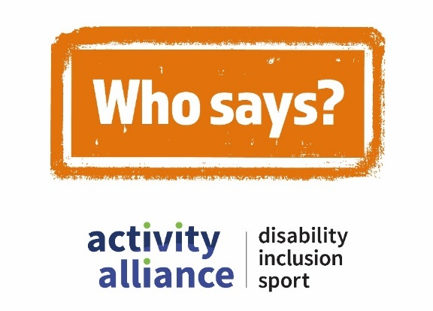

Transcript – Families can’t be active together film
This video shows action shots of disabled children and young people being active and playing different sports. While disabled and non-disabled children and adults talk about negative perceptions of disability, inclusion, and sport. It begins with quick scenes of people’s expressions, reactions, and responses to hearing the perception – Families can’t be active together.
School pupil, Thomas: “Nonsense.”
Two teenage boys with learning disabilities look at each other with confusion.
Sports coach, Sue: “They can!”
Onscreen text and voiceover reads: “Families can’t be active together.”
Who says campaign logo appears onscreen with a stamping sound.
Voiceover: “Who says?”
Cut to shot of an inclusive gaming session. Children with a range of impairments play video games together. Camera focuses on Powerchair user Rocket and his mum Marti.
Marti: “We’re really active. Really active family. We go walking, we’re always at the beach.”
Rocket nods his head in agreement.
Young video game player, Rosie: “I think they can. Because if they’re just active on their own, then they’re not spending time with each other, which is kind of important.”
Cut to shot of a parkour activity session. Visually impaired school pupils jump and roll on, over, and off soft boxes and obstacles.
School pupil, Emilio: “I go for walks with my new dog. I’ve got a puppy called Poppy. We love to go on bike rides. Dad and I play tennis together. We play golf together.”
School pupil, Thomas: “I’ve actually taught my brother how to play football.”
Cut to shots of a sport and activities event for young people with complex needs. Young people take part in obstacle races outside on an Astroturf pitch, while inside, other young people enjoy a relaxing yoga session. Camera focuses on siblings Charlotte and Daniel playing together while James speaks.
Event organiser, James: For me, it’s allowing them to be siblings and play.”
Charlotte drops the ball: “Sorry.”
James returns the ball to Charlotte.
James: It’s allowing them to be siblings, to play, make friends and build those relationships.”
Event organiser, Gemma: “That is the best way to be active as a family. If you’re all doing it together, you are all supporting each other. You’re probably not even realising you’re being active.”
Onscreen text and voiceover reads: “Call time on negative perceptions, #WhoSays.”
Who Says campaign logo appears onscreen with a stamping sound.
Video ends with Who Says campaign logo, Activity Alliance logo, and Sport England logo onscreen.
End of transcript.

