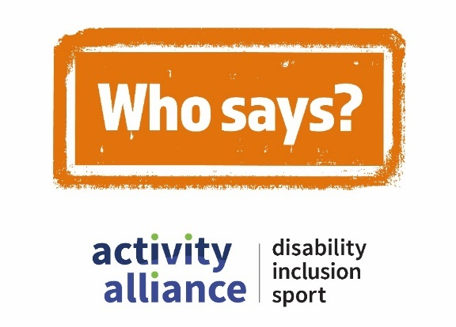

Transcript – Young disabled people should sit out of PE lessons film
This video shows action shots of disabled children and young people being active and playing different sports. While disabled and non-disabled children and adults talk about negative perceptions of disability, inclusion, and sport. It begins with quick scenes of people’s expressions, reactions, and responses to hearing the perception – Young disabled people should sit out of PE lessons.
Young video game player, Dylan: “No!”
Young video game player, Dayton looks disappointed, while organiser, Nicky shakes her head.
Charlotte, young girl in a wheelchair asks: “Why?”
Onscreen text and voiceover reads: “Young disabled people should sit out of PE lessons.”
Who says campaign logo appears onscreen with a stamping sound.
Voiceover: “Who says?”
Cut to shot of an inclusive dance class. Group of young disabled people clap and dance to the music.
Dancer, Jamie: “I just ignore those people, and then I go for it anyway.”
PE teacher, Mr Green: “My opinion is that’s a cop-out. If you’ve got a child with a visual impairment, you learn about that impairment. You learn how to adapt.”
Cut to shot of an inclusive gaming session. Children with a range of impairments play video games together. Camera focuses on Powerchair user Rocket and his mum Marti.
Marti: “They’re no different than anybody else. Everybody should have a chance. It’s heart-breaking watching them be told they’re not allowed to do something else.”
Cut to shot of a parkour activity session. Visually impaired school pupils jump and roll on and over boxes and obstacles. One boy perform a front flip on to a soft crash mat.
School pupil, Thomas: “I would never sit out of a PE lesson. Partially because I’m good at it, and I enjoy sports.”
Cut to shots of a sport and activities event for young people with complex needs. A young person works their way up the climbing wall, while some other children play games with hula hoops in a sports hall.
Event organiser, Gemma: “Most children who don’t have a disability have a huge choice of activities and sports that they want to take part in. And I think that disabled children should have that same offer.”
School pupil, Emilio: “This school have said I can do everything. And it just makes me really happy to be in school.”
Onscreen text and voiceover reads: “Call time on negative perceptions, #WhoSays.”
Who Says campaign logo appears onscreen with a stamping sound.
Video ends with Who Says campaign logo, Activity Alliance logo, and Sport England logo onscreen.
End of transcript.

