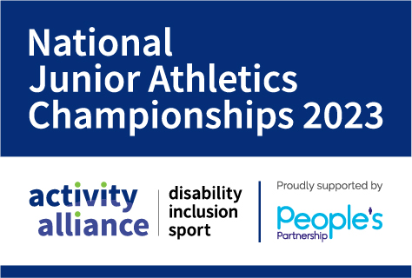

National Junior Athletics Championships 2023
Level 2 Licensed UKA Event

Individual entry information pack

Venue: Coventry Athletics Track, Warwick University, Kirby Corner Road, Coventry, CV4 8AH.
Date: Saturday 1 and Sunday 2 July 2023
Competitor entry fee: £45 (includes packed lunch and competitor t-shirt)
Entry fees are payable to: Activity Alliance. This can be done by BACs or PayPal. Invoices are available on request.
Completed entry forms and payment should be emailed to: Jannine@activityalliance.org.uk.
Please ensure you complete all relevant sections of this entry pack.
If you need to discuss any of the enclosed information, please do not hesitate to contact us by email at events@activityalliance.org.uk.

Entry information
The Championships will be run under the Activity Alliance Profile System, Further information on the Profile System can be found within the Profiling Toolkit resource on Activity Alliance’s website.

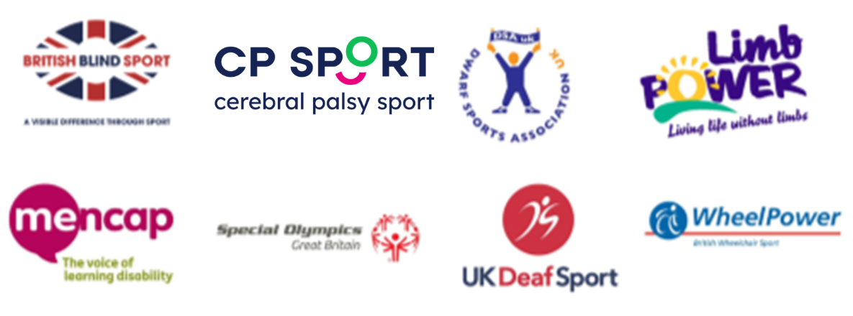

Rules
The competition will run under Activity Alliance Athletics Rules. The Activity Alliance rules are to be read in conjunction with World Para Athletics (WPA) Rules and the International Amateur Athletics Federation (IAAF) Rules.

Age Groupings
- Under 12 – competitors must be 9-11 years old at midnight on 31st August 2023
- Under 14 – competitors must be 12 or 13 years old at midnight on 31st August 2023
- Under 16 – competitors must be 14 or 15 years old at midnight on 31st August 2023
- Under 18 – competitors must be 16 or 17 years old at midnight on 31st August 2023
- Under 20 – competitors must be 18 or 19 years old at midnight on 31st August 2023

Competition Timings
The exact schedule of events will be generated once we have received the entries, however, the approximate timings of the weekend will be as follows:
- Saturday 1 July 2023 – 10:00am-4:00pm
- Sunday 2 July 2023 – 9:00am-12:00pm

Registration
There will be a Team Managers meeting via Zoom on Thursday 29 June an exact time will be confirmed.
Teams/individual athletes will register on the day of the competition. Please note that the final start sheets for the event will be posted online and printed immediately after the Team Managers meeting and no amendments or additions will be accepted on the day of competition.

Guesting in events
Competitors may guest in events if there is availability and space. As we will be on a restricted schedule this may not be possible. Activity Alliance will try to accommodate this where possible.

Medals
Medal and places will be awarded on the day.

Anti-doping
All entrants shall be deemed to have made him/herself/themselves familiar with and agreed to be bound by the UKA Anti-Doping Rules and to submit to the authority of UK Anti-Doping in the application and enforcement of the Anti-Doping Rules. The UKA Anti-Doping Rules apply to entrants participating in the sport of Athletics, for 12 months from the [date of entry], whether or not the entrant is a citizen of, or resident in, the UK.

Participant information
Please note that there is a group entry form available if you are entering more than one athlete.
First Name |  | Surname
Date of birth |  | Age
Male/Female |  | Tel.no
Address
Region/Country
Email

Medical information
Disability (please state):
Please indicate if you have any medical conditions or any other special requirements, we should be aware of e.g. asthma, epilepsy, allergies:
Type of reaction/ treatment required:
Current injuries or medical treatment:

Competitors Code of Conduct
We have a responsibility to promote high standards of behaviour in the sport. Competitors and staff will at all times be expected to adhere to the following minimum standard of behaviour and conduct.
- Respect the spirit of fair play.
- Take responsibility for my own behaviour.
- Respect the rights and dignity of others and never be involved in discrimination of any kind.
- Never use inappropriate language or gestures
- Always behave in a considerate way towards fellow participants, officials, profilers, event
- organisers and venue/hotel staff
- Protect others from verbal or physical abuse and threatening and intimidating behaviour.
- Never take part under the influence of alcohol or drugs
- Not possess any prohibited substances or performance enhancing drugs as set out within the national policies adopted by UK Sport and British Athletics
Activity Alliance reserves the right to withdraw competitors from the event if they do not keep to the contract. We do hope this will not be necessary.

Medical consent
This must be completed by the parent/guardian of any competitor under the age of eighteen years on the date of the competition.
I ..................................................................being parent/guardian of the named child on this entry form - hereby give permission for the School/Team Manager/Event Manager to give the immediate necessary authority on my behalf for any medical or surgical treatment recommended by competent medical authorities, where it would be contrary to my son/daughter’s interest, in the doctor’s medical opinion, for any delay to be incurred by seeking my personal consent.
Signature of Parent/Guardian ……………………………………………………….

Activity Alliance Safeguarding Procedures
At Activity Alliance we are committed to promoting the safety and welfare of all disabled people involved in sport and ensuring we promote the welfare of all children and young people and their rights to be protected from harm. Please ensure that you have read and understood Activity Alliance Safeguarding policies and procedures. Safeguarding resources are available to read on Activity Alliance's website. They will also be promoted prior to and will be available at the event.
I have read and understand the Activity Alliance Safeguarding Policies Yes/No (Please delete)
Signed: ________________________ Dated: ________________________

General Data Protection Privacy Statement
Activity Alliance take your privacy seriously and we will only use your personal information to provide the services and products that you have requested from us.
We would like to keep in touch with you from time to time about the work we do, our participation opportunities and fundraising appeals.
Please tick to confirm you are happy for Activity Alliance to contact you:
Yes, happy for Activity Alliance to contact me

Please tick to say how you would like us to contact you:
Post
Email
E-newsletter
Telephone
Text message

If you selected email, please let us know of your preferred email address:
Email address

Please tick to confirm you are NOT happy for Activity Alliance to contact you:
No, not happy for Activity Alliance to contact me

We will never sell your data and we promise to keep your details safe and secure. You can change your mind at any time by emailing events@activityalliance.org.uk or clicking the unsubscribe links if you no longer wish to receive our newsletters.

Costing and payment
 | Cost | Total | Payment method and reference
Competitor Entry  (Including packed lunch and Competitor t-shirt) | @ £45
 | TOTAL | £

Entry Fees are payable by the following methods:
- Cheque made payable to Activity Alliance
- BACs: Activity Alliance, Sort Code: 202409, Account Number: 00246727
- PayPal: Info@activityalliance.org.uk. Please use reference NJAC and name of athlete or school/group.
Invoices are available on request to Finance@activityalliance.org.uk.
Please note entries will not be accepted without accompanying payment if an invoice has not been requested.

Refunds
If a competitor withdraws from the event more than two weeks before the Championships, a full refund of the entry fee will be given, on the provision that Activity Alliance incurs no costs.
If a competitor/escort withdraws less than two weeks before the Championships NO refund will be given. All withdrawals should be notified to the Events Team as soon as possible, please ensure this is confirmed in writing.

Photography, film footage, and social media consent
It is intended that we will have an official photographer and social media Officers at the National Junior Athletics Championships.
In accordance with our safeguarding policies, we will not permit photographs, video or other images of a participant being taken or shared without the consent of the participant and the parents/carers of a participant under the age of 18.
From time to time we may also allow use of photographic images and videos by our sponsor People’s Partnership and or third parties. These will only be those with an official association with Activity Alliance.
Activity Alliance will take all steps to ensure these images are used solely for the purposes they are intended. If you become aware that these images are being used inappropriately you should inform Activity Alliance immediately.
Please complete the form below, selecting that you do or do not give your consent, to enable us to use these images to actively promote the work of Activity Alliance. Please sign the following statement.
I hereby grant/do not grant (delete applicable) Activity Alliance the absolute right to use the images resulting from this photo/film shoot. This includes any reproductions or adaptations of the images for all general publicity purposes, in print, on our website or social media sites, such as twitter, Instagram and Facebook.
Name of participant:
Signature of participant:
Signature of Parent / Guardian:
(If under the age of 18)
Date:

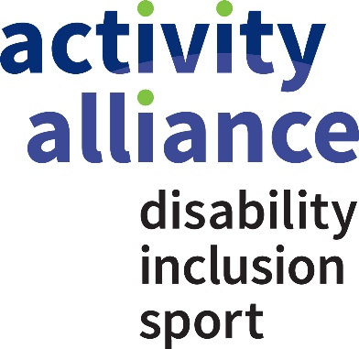

Entry information
Please note that there is a group entry form available.
First name |  |  | Surname
Date of birth |  |  | Sex |  | Male/Female
Age Group |  |  | T-Shirt Size (S, M, L,XL)
Region/Country
Athletics club (if any): |  |  |  | CP Sport membership No.
Activity Alliance Profile |  |  |  | WPC Class
Please fill in both the relevant profile and grouping, if your athlete has an WPC class, please use this above an Activity Alliance profile. For guidance on profiling please see the Profiling Toolkit resource on Activity Alliance’s website.

Events
Event 1 | Event 2 | Event 3 | Comment
For information on available events please see the ‘Event Info and National Standards Booklet’.
T11/12 or P37 competitors should indicate if they compete with a caller/guide.

Equality monitoring form
This form is for statistical purposes only.
Please highlight or put a X (cross) in the boxes and return with your entry.

Gender
Identified gender as: Male: Female: Prefer not to say:

Is your gender the same as registered at birth?: Yes: No: Prefer not to say:

Age
(Please tick) 8-12 13-14 15-16 17-18 19-20

Race
White – British White & Black Caribbean
White – Irish White & Black African
White – other background White & Asian
(Please state) ..................... Any other Mixed background
(Please state).....................

Indian Black Caribbean
Pakistani Black African
Bangladeshi Any other Black background
Chinese (please state) .....................

Arab/Middle Eastern Prefer not to say.
Any other background
(Please state)........................

Religion or belief
Buddhist Hindu
Christian Jewish
Muslim Sikh
Any other religion/belief None
Prefer not to say.

